A review of uninterruptible power supplies (UPS)

Syed Niaz Mohtasim, Jannat Un Nayeem Iqra
Department of Computer Science and Engineering
Independent University, Bangladesh
Dhaka, Bangladesh
Email : 2021607@iub.edu.bd , 2030087@iub.edu.bd

Abstract— Uninterruptible power supplies, commonly known as UPS, is a device which essentially provides instantaneous power backup to the device it is connected. This paper talks about the different classifications and the circuitry behind them, the components of a UPS, the applications or where they are used most commonly. This paper also discusses the different sources of power which power this uninterruptible power supplies. This paper hopes to give an adequate review on uninterruptible power supplies and all the things going on inside.
Keywords— uninterruptible power supply, uninterruptible power supply classification, uninterruptible power supply components, uninterruptible power supply applications, alternative power sources

Introduction
Uninterruptible Power Supply (UPS) system provide steady, clean, reliable and prime quality power for essential loads. The aim of uninterruptible power supply system is to safeguard the data, improve the standard of electrical network and save the user from the harmful consequences caused by electrical network pollution. Uninterruptible power supply system also plays role in industrial processing, medical facilities, telecommunication and many more departments.

The best uninterruptible power supplies deliver sinusoidal output voltage with low total harmonic distortion (THD) regardless of changes in the load or the input voltage. It should have the feature of zero switching time from normal to back up mode (low transients response time) and vice versa. Besides, it should have high efficiency, low cost, high reliability, low EMI and acoustic noise and low maintenance. [1]

Classification
There are three types of uninterruptible power supply system static, rotary, and hybrid static/rotary systems. This section, discusses these three categories of uninterruptible power supply systems

Static uninterruptible power supply
Static uninterruptible power supply are the foremost frequently used uninterruptible power supply system . The most advantage of using static uninterruptible power supply systems are high efficiency, high reliability and low THD. There are 3 styles of static uninterruptible power supply system online, offline and line interactive uninterruptible power supply system.
- Off-line uninterruptible power supply is additionally called “standby uninterruptible power supply” and is that the commonest kind of uninterruptible power supply which we encounter in our everyday life. As shown in figure 1, it consists of an inverter, a battery charger and battery, static switch, filter (to improve the output of voltage) surge suppressor (which prevent the output equipment from current spikes that can occur on the input line). [2] [3]
During the normal mode the switch is connected to the main supply and the load is fed directly by the power supply and at the same time the battery charger will charge the battery. When the power fails switch connect the load to the inverter and this time the load is fed by the battery, through the inverter. [1]
The switching time of the static switch is a smaller amount than 10 milliseconds, and this doesn't affect the traditional computer load. It’s feature like, simple structure , small volume ,low cost and straightforward control are advantage to the user. On the opposite hand lack of real isolation of the load from the AC line, lack of voltage regulation ,long switching time and poor performance with nonlinear loads are the most disadvantages. [4] [1]
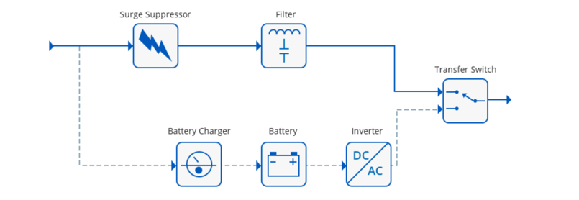
Figure 1 [5]

- Line Interactive uninterruptible power supply systems also called Voltage Independent operate similarly to an Offline uninterruptible power supply, with the addition of a built-in Automatic Voltage Stabiliser (AVS).
Line Interactive uninterruptible power supply encompasses an inverter, charger and battery, static switch and AVS (automatic voltage stabilizer) which helps to control voltage. An optional output filter is often added either at the output of the inverter or at the input side of load. Line Interactive uninterruptible power supply can function both as an on-line or off-line uninterruptible power supply. However, maximum of the line interactive uninterruptible power supply function as online to enhance the power factor or regulate the output voltage for load. [2]
During the normal mode, the main supply provide power to the load and therefore the charger charges the battery. At the time of breakdown, the switch connects with inverter and the battery supplies power to the load through the inverter. [1]
Advantage of using line interactive uninterruptible power supply is it's high reliable, cheap and little size and because of its single state conversion topology, the efficiency is higher compared to double conversion uninterruptible power supply. The main disadvantage is that the lack of effective separation of the load from the supply input. Adding a transformer can put an end to this but this increases the price and weight of the uninterruptible power supply system. Compare to off-line uninterruptible power supply, line interactive uninterruptible power supply is better but it still has some transitioning time that will elapse when the line input power fails. [3] [2]

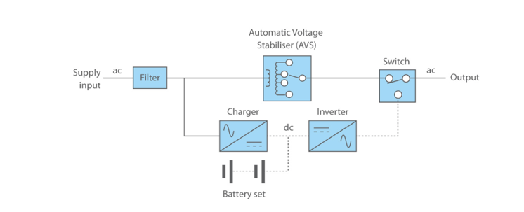
Figure 2 [5]

- Likewise, the off-line uninterruptible power supply system, the on-line uninterruptible power supply system is that the popular and most used configuration. Online uninterruptible power supply is additionally referred to as “double conversion uninterruptible power supply” and it's also expensive. It comprises rectifier/charger, battery set, inverter and a static switch. In Online uninterruptible power supply during normal mode, the input line isn't connected to the output. [6] [3]
During normal operation, the input power at first passes through (battery charger) AC to DC converter where the DC voltage is used to charge up the battery set. The battery then discharges through an inverter DC to AC converter and then goes to the load. During the power failure, the battery provides power to the load through the inverter without any interruption. Thus, inverter plays role in both the mode. The inverter supplies clean, and conditioned power to the load no matter the harmonics and variations within the grid voltage. Just in case if the inverter, battery or battery charger fails, line voltage will go through the static switch to reach the output. [1] [3]
Advantage of Online uninterruptible power supply is that there's an efficient isolation between the load and also the input power and also the switching time is also negligible during power outage. One of the most benefits of an internet uninterruptible power supply system is that it provides the best level of power protection to your critical load from power ‘events’ like spikes, sags, surges, electrical noise, and so on.
The major drawbacks of online uninterruptible power supply are that it uses a great deal of power and therefore the power which was consumed is released as heat and greatly affects the efficiency. [3]
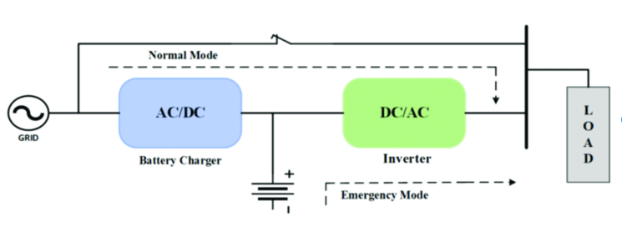
Figure 3 [7]

Rotary uninterruptible power supply
Rotary uninterruptible power supply incorporates an AC motor, DC machine, AC generator and battery bank. Rotary uninterruptible power supply have two operating modes normal mode and stored energy. During the conventional mode, AC line provides power to AC motor which drives the DC machine and the DC machine drives the AC generator. AC generator then supplies power to the load and during power failure, battery bank supplies the DC machine, which drives the AC generator and AC generator supplies the load .Compare to static uninterruptible power supply, rotatory uninterruptible power supply is more reliable but it needs more maintenance and it has more weight. [2]
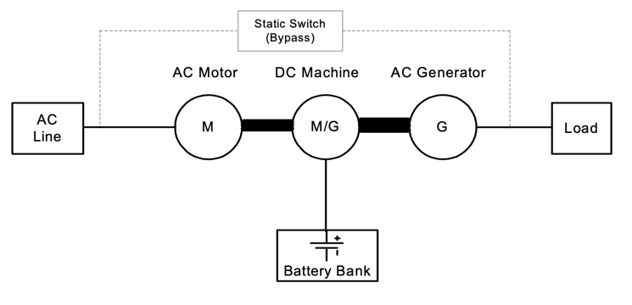
Figure 4 [2]

Ferroresonant or Standby-Ferro uninterruptible power supply
Ferrorresonant is an improvement on the planning of offline uninterruptible power supply. The foremost difference between offline uninterruptible power supply and stand-by ferro uninterruptible power supply is that the Standby’s uninterruptible power supply transfer switch that selects between power source is replaced by a transformer which has three windings (power connection). Two are input and one is output, which allows the transformer to act as a switch. The transformer includes a core of metal with two coils of wire wrapped around, when the current is applied to one coil the opposite coil magnetically couple to the primary coil and induce current. [3] [7]
During the normal mode, input power passes through the a transfer switch, through the transformer and then to the load. Just in case if power fails transfer switch is opened and therefore the battery supplies the power through the inverter to the load. within the Standby-Ferro design, the inverter is within the standby mode, and is energized when the input power fails and therefore the transfer switch is opened. [7]

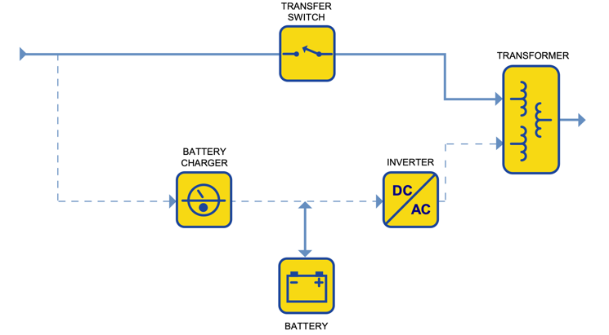
Figure 5[7]

Hybrid Static/Rotary uninterruptible power supply
Hybrid static /rotary uninterruptible power supply consist features of both static and rotary uninterruptible power supply systems. They have high reliability, better frequency stability and low maintenance requirements. Fig.6 shows a typical hybrid uninterruptible power supply which consist of AC/DC converter, battery bank and a static switch. Hybrid uninterruptible power supply are used commonly in high power application. [2]

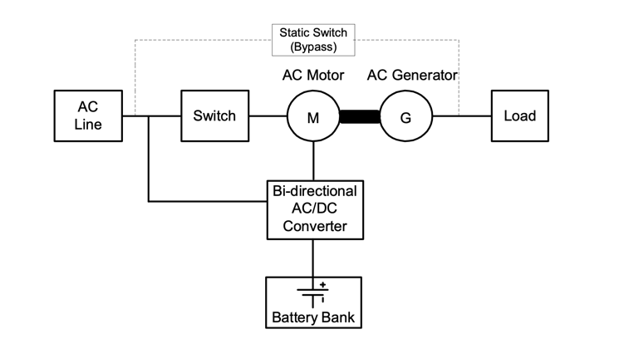
Figure 6[2]

The common Components
The purpose of each uninterruptible power supply system is same , to prevent the load from powering down or being damaged . Each uninterruptible power supply have different sub-components. This section will discuss about uninterruptible power supply components and their roles.

Rectifier/ Charger
Rectifier carries out several key functions. One is to charge the battery so it remains at proper float voltage. Another purpose of rectifier is to convert the input power from AC to DC. Counting on the dimensions of the uninterruptible power supply, the rectifier module may incorporate the charger. With smaller uninterruptible power supply systems (i.e. below 3 kVA) it's not uncommon for the rectifier and charger to be separate components. uninterruptible power supply rectifiers can accept extensive input voltage variation, which means system can handle overloads or surges without having to communicate with the batteries. [8].
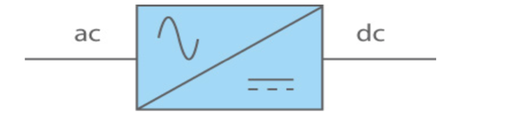
Figure 7 [8]

Battery
Battery provides power supply to the load in case if the power fails. Rectifier/Charger make sures that the battery is always charged. uninterruptible power supply battery systems have a minimum of one string of batteries. Depending on DC voltage of the uninterruptible power supply the quantity of batteries in a string varies. Batteries within a string are connected in series, so if one battery fails so do the whole string. [9] [8]


Figure 8 Battery symbol [8]
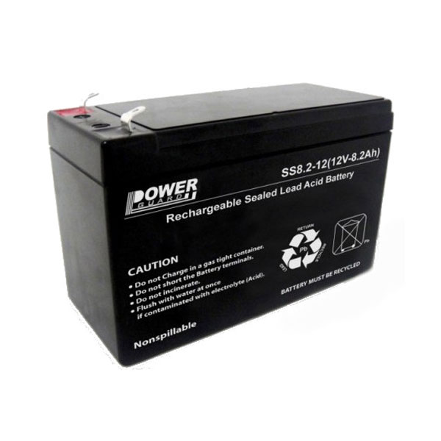
Figure 9 Typical UPS Battery [11]

Inverter
The inverter provides the last half of our double conversion uninterruptible power supply power grid process, by converting DC power from the rectifier/battery back to AC power. we would have liked DC power to charge the uninterruptible power supply battery, but it’s AC power that’s required by your critical loads, so this secondary conversion process is important. This conversion process (AC to DC to AC) smooths out events like spikes, sags, surges, and electrical noise, ensuring the ultimate output could be a pure sine waveform. [8]
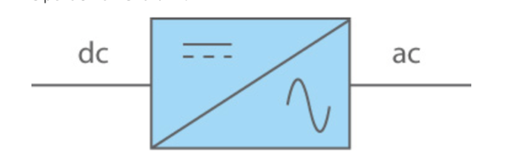
Figure 10 Inverter [8]

Static Switch
This component may be a safeguard just in case there’s a failure within the uninterruptible power supply system. During power failure, the static bypass switch automatically connects the load to the mains supply, passing through the rectifier, batteries, and inverter. Transferring the mains supply directly isn’t ideal as the input line won’t be filtered, but it allows equipment to function until the uninterruptible power supply is repaired.
[9] [8]

Static Suppressor
Surge suppressor is a vital component. When the load is not completely separated from the main supply there is a need to prevent the output equipment from current spikes. Surge suppression is usually done by placing an inductor on the input line. Inductor will resist any sudden change in current and will help to reduce the chance of any damage to the output. [3]

Filter
Filter remove any noise that may be getting introduced from the input line. The filter consists of inductors, resistors and capacitors to allow 60 Hz voltage to pass removing any unwanted higher or lower harmonic frequencies [3]

Applications
UPS is used anywhere where keeping an electrical device powered on at all times is absolutely essential. As mentioned earlier it is used for personal computers at homes, where power cuts are frequent. Power cuts lead to the device being unexpectedly shutdown and that could lead to data loss, or worse yet power surges could damage parts of the computer.[12]
In this modern day of technology and information, data is collected, stored and used everywhere. A power cut or surge could lead to data being lost from where its stored, from data servers. So, data servers are installed with UPS to prevent potential loss of data. [13] These devices do not require the longest backups, just enough time to turn the device off properly. [1]


Figure 11 Data Server Room [14]
UPS are used in the banking sector where any moment a transaction fails to follow through, revenue is being lost. So, they are used for the bank’s servers, its ATMs and Electronic Point of Sales (EPOS) to prevent any disruption. [12]
UPS are also crucially used in hospitals for electronic medical and diagnostic devices such as for ventilators and MRIs. [12] Ventilators and other crucial medical equipment cannot tolerate any loss of power for even a single moment for it could lead to loss of life. UPS should provide sufficient backup until a generator is turned or power from the grid is restored. [1]. Medical equipment which requires power backup include ventilators, power saws and electro drills for surgery, diagnostic devices such as x-rays and many more. [15]

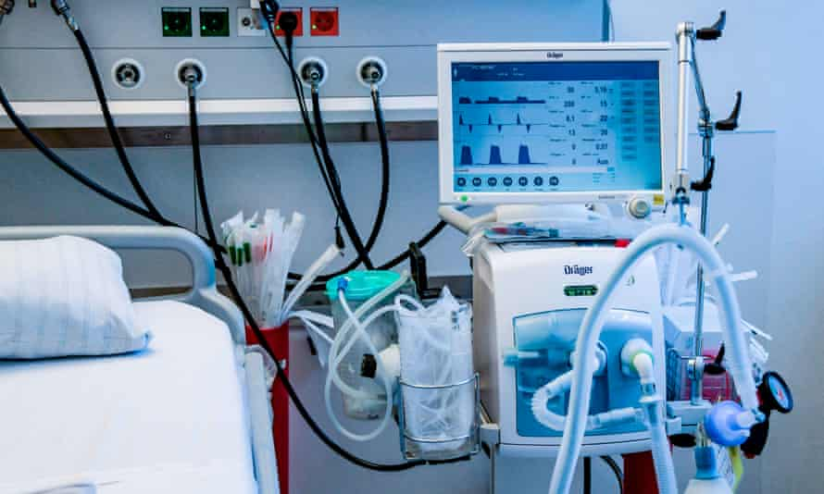
Figure 12 Ventilator [17]
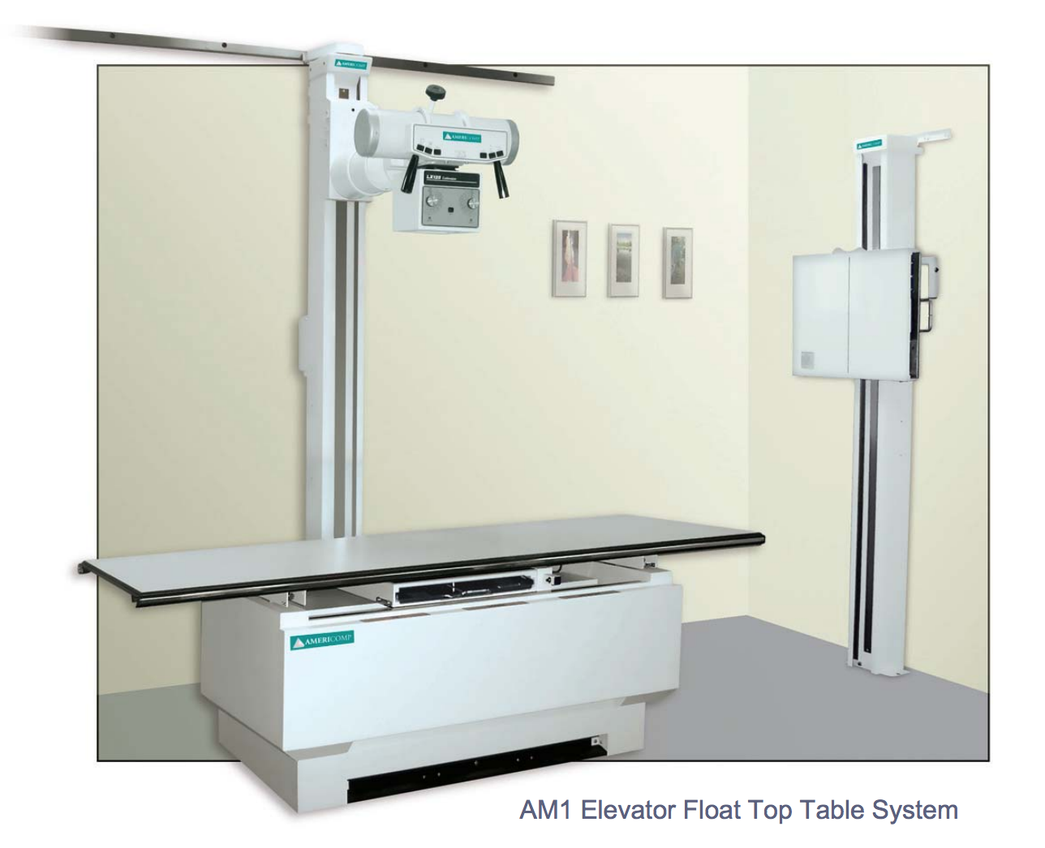
Figure 13 XRay Machine [16]

Sources of Power

Lead-acid
For the longest time UPS have used lead-acid batteries as the power source. Lead-acid batteries were first made almost 150 years and despite that they are still widely used particularly for good reason. They are able to provide significant amount of power in a short time yet they do not encounter issues if they are not used frequently. [18]. They are able to provide backup ranging from 5 to 15 minutes. One of the primary reasons behind using lead-acid battery is that it is still the cheapest option compared to the power backup it provides. However, lead acid batteries contain sulfuric acid which is highly toxic which is not ideal if the battery has a leak. And due to the sulfuric acid, it is also very expensive to dispose these batteries. They have a life span of 5-6 years. Lead-acid batteries tend to be very heavy and bulky so they do not offer a great power to weight ratio. [18]
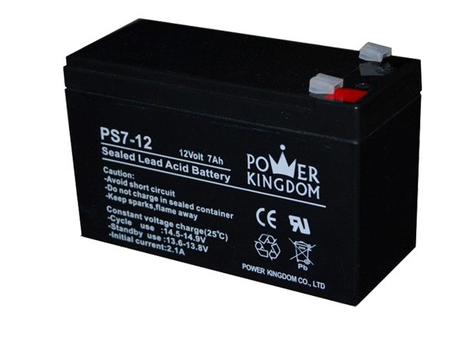
Figure 14 Lead-Acid Battery [19]

Lithium-Ion
Lithium-ion have become very popular due to them being the source of power behind smartphones and laptops, which themselves have become very popular and essential for people nowadays. They are very compact and they have good backup capabilities. They have a long lifespan of 10 years. However, they are not yet as cost friendly as compared to lead-acid batteries but as technology advances, the difference of cost falls. Lithium-ion battery have a chance of exploding if they are overcharged or overheated. Lithium-ion batteries’ small size and high density makes it an attractive alternative to the traditional lead-acid batteries. Lithium-ion batteries are also used for hybrid and fully electrical vehicles. Many experts believe lithium-ion will the primitive lead-acid battery. [18]
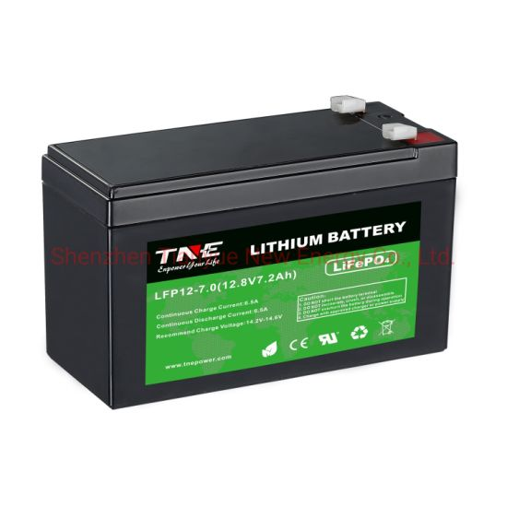
Figure 15 Lithium-Ion 12V Battery [20]

Flywheel
Flywheels are very old and are used in internal combustion engines. They essentially store energy when a disk or rotor rotates on its axis. [21]. The disk generates DC current which can be used as power for UPS. Flywheels are smaller compared to lead-acid batteries and they do not contain or produce any toxic chemicals. They have a long lifespan of 10 years and they do not cost much to maintain. However, flywheels have an extremely short backup time of around 30 seconds. Companies could install multiple flywheels but that still means a backup of a few minutes. Flywheels are also expensive due to the cost bearing, which also has to be replaced every five years. Flywheels is good for specific scenarios such as when there is a generator present, which has to be turned on, so the few seconds backup is actually ideal in this case. Flywheels are mostly used for hybrid solutions, where the flywheel is paired with another source of power like a battery, which deals with the longer outages. This actually helps to extend the life of the batteries. [18]
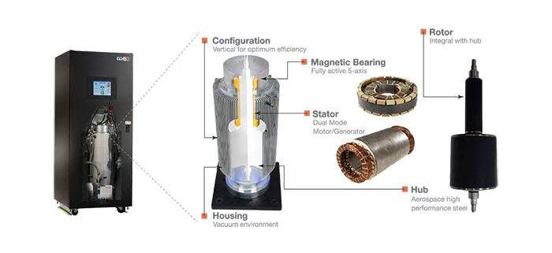
Figure 16 Flywheel [22]

Supercapacitor
Supercapacitors, just like flywheels, also provide backup only for a few seconds. [1]. They happen to be a non-mechanical alternative which also do not contain or produce any toxic material. They are small in size and they have no maintenance. However, as mentioned earlier it has short backup time and they still cost almost double the price of a similarly powered lead-acid battery. Prices will and have to go down before it can be considered as a viable option for the consumer market. [18]
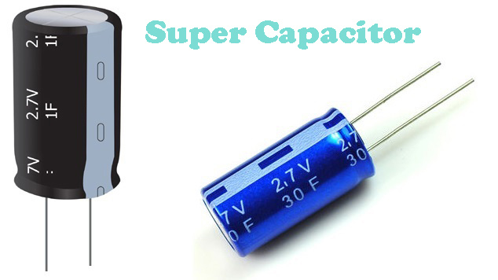
Figure 17 Supercapacitor [23]

Fuel Cell
Fuel cells are similar to internal combustion engines in the sense they both produce power rather than storing from a fuel. But internal combustion engines produce greenhouse gases as a byproduct on the other hand hydrogen fuel cells produce water which makes them environmentally friendly. They also provide power for as long as it is provided fuel so they have a long backup span. However, fuel cells are still very costly compared to lead-acid batteries. Hydrogen is flammable so it must be handled with caution and stored in an orderly and safe manner. Fuel cells also take time to start up, about 30 seconds so fuel cells UPS have a small battery to provide power for the first few seconds. Manufacturers are look nonflammable fuel alternatives for fuel cells but the cost remains high enough so it will be a while before it starts into the market of lead-acid batteries. [18]
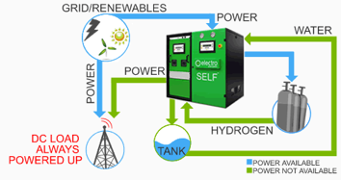
Figure 18 Hydrogen Fuel Cell Battery [24]

Conclusion
Technology is evolving at a rate of knots and it shows no signs of slowing down. Even in the case of uninterruptible power supplies, which does its job pretty well when the right one is selected for the right situation, there is no slowing in the stride to improve. New battery technologies are becoming cheaper every year hence leading to more options for a power source. Hybrid solutions also offer an interesting choice to potentially improve efficiency and reduce costs. The main circuitry behind each classification of uninterruptible power supplies has not changed since it was first made. But as mentioned, people are always looking to make changes to the inside of the uninterruptible power supplies to make them more viable and affordable. Uninterruptible power supplies are becoming much more common and in fact more of a necessity as the need to keep power on at all times becomes more important and this paper hopefully gives you a brief but solid foundation about uninterruptible power supplies and its types and the circuitry behind each type, the common components of uninterruptible power supplies, the most frequent applications or uses of uninterruptible power supplies and the different sources of power being tried and tested for uninterruptible power supplies.

References

[1] | K. A. K. S. M. Muhammad Aamir, "Review: Uninterruptible Power Supply (UPS) system," 2016.
[2] | E. Bekiarov, "Uninterruptible Power Supplies: Classification, Operation, Dynamics, and Control," 2002.
[3] | P. R. Racine, "AN OVERVIEW OF UNINTERRUPTIBLE POWER SUPPLIES".
[4] | Y. L. Xuemei HU, "Principle and Running Maintenance on UPS Power Supply," in International Conference on Electronic & Mechanical Engineering and Information Technology, Nanyang, China, 2011.
[5] | "Riello UPS America," [Online]. Available: https://www.rielloupsamerica.com/questions/29-what-is-an-offline-ups.
[6] | M. A. S. K. W. Muhammad Ali, "Research Gate," December 2018. [Online]. Available: https://www.researchgate.net/publication/329649738_Lyapunov_Stability_and_Performance_Analysis_of_the_Fractional_Order_Sliding_Mode_Control_for_a_Parallel_Connected_UPS_System_under_Unbalanced_and_Nonlinear_Load_Conditions#pf3.
[7] | N. Rasmussen, 2005. [Online]. Available: https://www.apcdistributors.com/white-papers/Power/WP-1%20The%20Different%20Types%20of%20UPS%20Systems.pdf.
[8] | "Constant Power Services," [Online]. Available: https://www.constantpowerservices.com/questions/4-what-are-the-main-components-of-a-ups-system.
[9] | "Kohler Uninterruptible Power," 13th August 2015. [Online]. Available: https://www.kohler-ups.co.uk/directors-blog-the-four-main-components-of-a-modern-ups/.
[10] | H. S. Khan, "ResearchGate," february 2019. [Online]. Available: https://www.researchgate.net/figure/Block-diagram-of-the-online-uninterrupted-power-system-UPS_fig1_331071312.
[11] | "Global Brand BD," [Online]. Available: https://www.globalbrand.com.bd/product/power-guard-ups-battery-price-in-bangladesh/.
[12] | "UNINTERRUPTIBLE POWER SUPPLY APPLICATIONS," [Online]. Available: https://www.eneria.fr/en/energy/uninterruptible-power-supply/ups-applications/.
[13] | "UPS Applications and Selecting Uninterruptible Power Supplies," [Online]. Available: https://www.criticalpowersupplies.co.uk/ups-applications.
[14] | "Rack Solutions," 2020. [Online]. Available: https://www.racksolutions.com/news/blog/how-many-servers-does-a-data-center-have/.
[15] | G. A. A. A. Zhitkov O.M., "Application of the uninterruptible power supply systems in medicine," Modern Techniques and Technology. MTT'2000 (Cat. No.00EX369), 2000.
[16] | "South West XRay," 2018. [Online]. Available: https://southwestxray.com/x-ray-machine-price/.
[17] | G. Readfearn, "How ventilators work and why they are so important in saving people with coronavirus," 2020. [Online]. Available: https://www.theguardian.com/world/2020/mar/27/how-ventilators-work-and-why-they-are-so-important-in-saving-people-with-coronavirus.
[18] | E. Spears, "Emerging UPS standby power sources," Eaton, 2017. [Online]. Available: https://www.eaton.com/content/dam/eaton/products/backup-power-ups-surge-it-power-distribution/backup-power-ups/ups-batteries-resources/eaton-emerging-ups-standby-power-sources-Alternatives-Acid-Battery-whitepaper-WP162002EN.pdf.
[19] | "Wirtz USA," 2017. [Online]. Available: https://www.wirtzusa.com/lead-acid-battery-maintenance-basics/.
[20] | "TNE POWER," [Online]. Available: https://tnepower.en.made-in-china.com/product/VKSmtneobbpM/China-12V-7ah-Lithium-Ion-Battery-to-Replace-Lead-Acid-UPS-Battery.html.
[21] | D. R. B. C. &. W. D. C. CEM, "Flywheel Energy Storage: An Alternative to Batteries," Energy Engineering, 2005.
[22] | "Quality Power Solutions," 2017. [Online]. Available: https://www.qpsolutions.net/2017/06/intro-to-the-flywheel-ups-powered-by-motion/.
[23] | "Circuit Digest," 2018. [Online]. Available: https://circuitdigest.com/tutorial/an-introduction-of-supercapacitors.
[24] | "Zoom Team," [Online]. Available: http://www.zoomteam.com/Fuel_Cell_UPS.html.

